Emergency Works Notification

Date : 7th January 2025
Permit Number : UC0703591-01
Statutory Undertaker : Milestone
Location : Taylors Road, Stotfold (by Tudor Oaks)
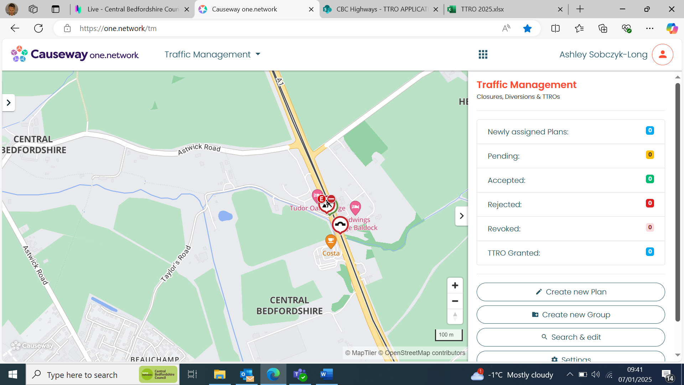
Traffic Management : Road closure
Duration : 6th –10th January
Emergency Responded to : Flooding
Action Taken : Closure in place

